 |  |  |  |  |  |  |  | 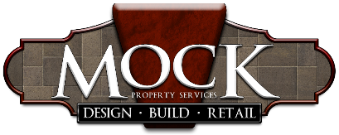
Mock Property Services, Inc.
Job Title: |  | Retail Associate |  |  |  |  |  | Type of Position: |  | Hourly
Department: |  | Retail Store
Reports to:
 | DUTIES AND RESPONSIBILTIES
1.) Be customer service oriented, meet and greet with a smile
2.) Identify needs/wants of each customer
3.) Make recommendations based on their "pain" or grand idea
4.) Describe product features and benefits
5.) Arrange, display, suggest and demonstrate the use and operation of a product when necessary
6.) Provide financing option of Synchrony Financial
7.) Receive and process cash, check and credit card payments
8.) Provide change and receipts
9.) Count and balance cash drawer and prepare deposit
10.) Organize and process merchandise returns/exchanges according to our return policy
11.) Stay current with sales and promotions
12.) Keep store neat, clean and organized
13.) Assist with classes/seminars held for customers
14.) Be willing and prepared to work in variable weather
15.) Be comfortable with handling plants and fish
16.) Knowledge of customer service principals/process
17.) Some experience in retail, customer service or sales environment preferred, but not required
18.) Honesty, integrity, punctuality and good work ethic are a must
19.) Valid driver's license, insurable, negative drug test

