 |  |  |  |  |  |  |  | 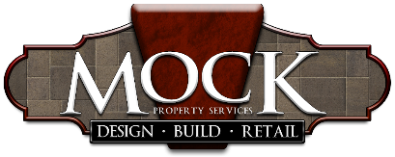
Mock Property Services, Inc.
Job Title: |  | Lawn Care Tech |  |  |  |  |  | Type of Position: |  | Hourly
Department: |  | Lawn Care
Reports to:
 | DUTIES AND RESPONSIBILTIES
1.) Perform lawn duties such as: mowing, leaf blowing, debris removal, weeding, edging, raking, trimming
2.) Helping to ensure neatness, completion and customer satisfaction
3.) Maintain assigned materials/equipment to maximize useful life
4.) Assist in Cleaning and organizing truck/tools/supplies
INITIAL DUTIES
1.) Learn lawn care department procedures and policies
REQUIRED QUALIFICATIONS
1.) Ability to communicate well with customer
2.) Self-motivated and driven
3.) Ability to follow systems and procedures
4.) Team player and growth minded
5.) Committed to the values of honesty, pride in work, respect, and efficiency
6.) Navigate over rough/uneven terrain
7.) Bend, kneel, and reach
8.) Lend a helping hand to another crew under a tight deadline
9.) Valid driver's license, insurable, negative drug test

