 |  |  |  |  |  |  |  | 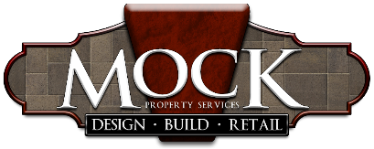
Mock Property Services, Inc.
Job Title: |  | Lawn Care Crew Leader |  |  |  |  |  | Type of Position: |  | Hourly
Department: |  | Lawn Care
Reports to:
 | ESSENTAIL DUTIES AND RESPONSIBILTIES
1.) Perform lawn duties such as: mowing, leaf blowing, debris removal, weeding, edging, raking, trimming
2.) Responsible for job neatness and completion, crew efficiency, time management
3.) Maintain assigned materials/equipment to maximize useful life
4.) Maintain customer relations, correspondence, and quality control walk-throughs
5.) Develop relationships within the existing customer base
6.) Drive customer satisfaction and loyalty
7.) Clean/Maintain and organize truck/tools/supplies
INITIAL DUTIES
1.) Learn office and lawn care department procedures and policies
2.) Analyze efficiency and develop strategy/ plan to increase efficiency and reduce cost
REQUIRED QUALIFICATIONS
1.) Outstanding customer service skills- ability to turn transactions into relationships
2.) Strong ability to recover quickly from a service failure
3.) Innovative thinker
4.) Superior organizational skills both administratively and practically
5.) Self-motivated and driven
6.) Problem solver
7.) Ability to develop systems and procedures
8.) Team player and growth minded
9.) Committed to the values of honesty, pride in work, respect, and efficiency
10.) General computer skills
11.) Navigate over rough/uneven terrain
12.) Observe and inspect outdoor spaces
13.) Bend, kneel, and reach
14.)Lend a helping hand to a crew under a tight deadline
15.) Valid driver's license, insurable, negative drug test

